Agility Team GB
International Qualifiers 2025 for the
2026 Adult Try Out Qualification

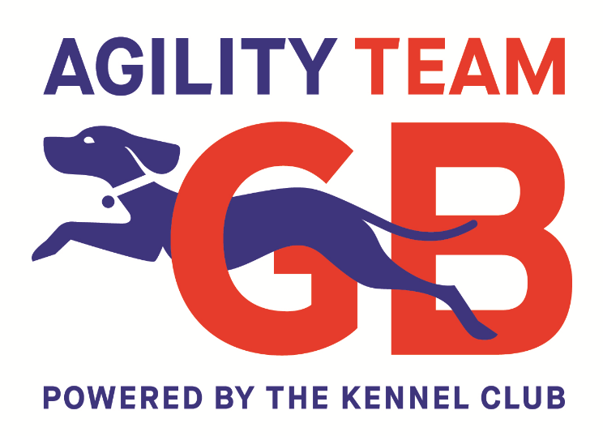

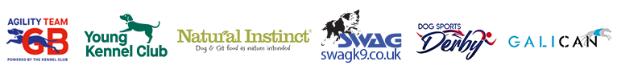

Agility Team GB – OPEN TO ALL

International Agility Team Manager – Greg Derrett
Email Address: agility.gbmanager@thekennelclub.org.uk

The Kennel Club - Events Planning Manager – Gina Sansom
Contact Number: 01296 318540
Email Address: agility@thekennelclub.org.uk

Background
This document outlines details about the 2025 Agility Team GB qualification process to qualify for the adult try-out weekends for the 2026 European Open and Agility World Championships.
The rationale behind the International Qualifiers is to create a selection process through more appropriate competitions & course designs. The Kennel Club hopes that this will achieve many benefits including the following;

- Qualification for the selection process is from the correct level and style of course, using FCI specifications and rules.
- By qualifying on these courses, partnerships will already have demonstrated they have the appropriate international skills to compete in the Agility Team GB selection process.
- Enhance the skills of all current and future partnerships on international courses.
- Expose future handlers to the skill set needed for International Championships and allow them to identify their current skill level in a competition environment. Future partnerships can also gauge their competitiveness against top GB dogs and handlers on international courses.
- Provide appropriate competitions for the current year’s team to prepare them for the International Championships.
- To provide international courses to the section of the Agility community that wish to run these without altering other KC Prestige Events.
- Offer handlers international style competitions in the UK rather than requiring them to travel into Europe to improve.

International Qualifiers (IQ).
The following clubs have been awarded an Agility Team GB International Qualifier in 2025.
Date | Club Name | Address
25 April | Lincoln Agility Enthusiasts | Winterton Agricultural Showground, Holmes Lane, Winterton, DN15 9UG
23 May | Nottingham Agility DTC | Newark Showground, Lincoln Road, Newark-On-Trent- Nottinghamshire NG24 2NY
15 June | Kingdom of Fife | Kinross Polo Club, North Kilduff Farm, Kinross, KY13 0PN
28-29 June | PointZero Agility | Onley Grounds Equestrian Centre  Onley Grounds Farm  Willoughby  Rugby  Warwickshire  CV23 8AJ
23-24 August | Dog Sport Derby | Dog Sports Derby, Broughton Heath Road, Church Broughton, Derby, DE65 5BE
31 August | Gillingham (Dorset) Dog Training Society | Turnpike Showground, Motcombe, Dorset, SP7 9PL
6-7 September | Ogilvie Dogs | Isla Farm, 4 Northdrove, Twenty, Bourne, PE10 0BJ

Rules
- Open to Kennel Club registered dogs Grade 3-7
- All dogs must compete in their FCI jump height and must have received an official FCI Championship measure or a GB Height classification before the day of the IQ they are competing at. Failure to have one of the above will mean the result will be void and not count in any way towards qualification for the Try out process.
- Each height is a separate class.
- To be judged under FCI rules and regulations (except for contact equipment specifications which can be KC or FCI specifications.)
- Consists of a Jumping round and an Agility round with the results combined.
- Cumulative scoring: least faults win with time as tiebreaker only, in all aspects of the event.
- Running order for each class will be a random draw.
- Handlers running more than one dog will have a gap of 10 dogs (9 dogs between their runs, for example #2 and #12).
- If there are not enough dogs in the class to achieve the 10-dog gap, the largest gap possible will be created, with a break of 6 minutes allowed. The 6-minute countdown will start as the handler’s first dog crosses the finish line. The handler must enter the ring with their second dog before the countdown is complete.
- In the event of a tie for the winner of each class, the dogs will compete in a run-off.
- In the event of a tie for the Overall result, the scores from the Agility round will determine the winner. If there is still a tie for the top two overall places, the dogs will compete in a run-off on the Agility course.
- Eliminations in either round will not be placed in the Overall result.

Format
- Outdoor ring size must be a minimum of 40m x 32m minimum. Indoor arenas must be a minimum of 40m x 20m
- Surface must be appropriate. Flat mowed field, sand arena, astro turf.
- Equipment supplier to be approved by GB management.
- The course designers to be appointed by Agility Team GB management with the aim of using the current years EO and AWC judges to design courses.
- Course plans to be sent to the Agility Team GB management direct from the designing judge. Course plans will be submitted to the show judge 48 hours before the event. An equipment list will be agreed with the show management in advance.
- On site Judge appointed by show but approved by Agility Team GB management.
- Entry Fee is £25. This entry fee is the combined total for entering into both rounds (Agility and Jumping).
- £16 of the entry fee to be used by the show to cover all costs related to the event.
- £9 of the entry fee to be used by Agility Team GB to cover the Course designer’s fee and administration costs. See the Information to Club section.
- The show manager is responsible for the running of all aspects of the event on the day in collaboration with the show judge.

Qualification for Agility Team GB Try-Out Process 2026
The qualification dates will run from April 1 2025 through February 10 2026.

To be eligible to attend the Agility Team GB Try Out process in 2026, ALL partnerships MUST compete (run both classes) at a minimum of two (2) International Qualifiers during the qualification dates.

Plus partnerships must meet at least one of the following criteria;
- IQ Class winner.
- IQ Top Two Overall placement.
- Championship Certificate (CC) Winner (in equivalent KC height).
- Current year GB team member.

In addition, the Agility Team GB Management may select dogs who have not met the above criteria to join the process due to extenuating circumstances as determined by the management team.

Qualification numbers in 2026 Try Out process
For each height
- 14 IQ class winners (2 per heat)
- 14 IQ overall winners/runner ups (2 per heat)
(Placements do not roll down if a partnership has already qualified)

- 26 CC winners from Kennel Club shows between April 1 2025 through February 10 2026.

54 maximum total partnerships qualifying for the Try Out Process.

- Previous year’s team (8-10)

Potentially 64 dogs per height.
It is an assumption that this number will be greatly reduced as partnerships will take multiple places.

Awards
It is up to the hosting club’s discretion what awards they would like to present. However, we advise that the following is considered:
Rosettes
1st place in each class per height
1st and 2nd place in the combined result per height
No trophies need to be given unless the club wishes to award these.

